CHAPTER 3
METHODOLOGY
3.1 Introduction
This chapter presents the systematic approach used in the design and development of the Web-Based Reservation and Scheduling System for School Venues and Equipment at the Palompon Institute of Technology (PIT). It includes the research design, development methodology, system design, data gathering procedures, tools and technologies used, data analysis, evaluation procedures, and ethical considerations to ensure that the system meets its functional, usability, and security objectives.

3.2 Research Design
The study utilized an Applied Research design, specifically focusing on system development. This design was selected because the study aims to address a real-world institutional problem, particularly the inefficiencies and lack of real-time visibility in PIT’s current manual reservation process.
The research follows a Qualitative-Technical approach:
- Qualitative Approach – Data were gathered through informal interviews with students and personnel to identify existing issues in reserving facilities such as the PIT Multi-Purpose Gymnasium and CHIC Conference Hall.
- Technical Approach – Software engineering principles were applied to automate the manual multi-level approval workflow into a secure and efficient web-based system.

3.3 Research Locale
The study was conducted at Palompon Institute of Technology (PIT), located in Palompon, Leyte. The institution serves as the primary setting where the proposed system will be implemented and evaluated.

3.4 Participants/Respondents
The respondents of the study include student organization presidents and faculty members who request reservations, as well as custodians and Supply Office personnel involved in the approval process.
The study utilized purposive sampling to select participants who are directly involved in the reservation workflow. An estimated total of 30 respondents participated in the system evaluation.

3.5 Development Methodology
The study utilized the Iterative Development Model as the System Development Life Cycle (SDLC). This model was chosen because it allows continuous feedback and refinement, which is essential in developing systems with complex workflows such as multi-level approval processes and hybrid resource management.
The phases of development include:
- Requirements Analysis
Data gathered from interviews were analyzed to identify system requirements, including real-time scheduling, approval workflows, and centralized monitoring.
- System Design
The system architecture was designed using Role-Based Access Control (RBAC) to differentiate user roles such as requesters, custodians, and administrators.
- Implementation
The system was developed as a web-based platform accessible through desktop and mobile devices, allowing users to perform reservations and approvals online.
- Testing and Integration
All system modules were tested and integrated to ensure proper functionality, reliability, and accurate workflow execution.

3.6 System Design and Architecture
The system is designed to efficiently manage institutional resources, including venues (e.g., Balay Alumni Function Hall and PIT Oval) and equipment (e.g., sound systems, canopies, and industrial fans).

The design is supported by diagrams such as Data Flow Diagrams (DFD) and Use Case Diagrams to illustrate system processes and user interactions.

3.6.1 Resource Management Logic
To prevent scheduling conflicts and over-allocation, the system implements a dual-logic approach:
- Time-Slot-Based Scheduling – Applied to venues, allowing reservations based on available time slots.
- Quantity-Based Allocation – Applied to equipment, where availability depends on total inventory and active reservations.

3.6.2 Security Features
To ensure data protection and system integrity, the following measures are implemented:
- Secure Authentication – Password hashing (e.g., bcrypt) and HTTPS protocols are used to protect user credentials and data transmission.
- Role-Based Access Control (RBAC) – Ensures that users can only access features relevant to their assigned roles.

3.6.3 Multi-Level Approval Workflow
The system replicates the institution’s manual approval process in a digital format:
- Submission – The requester submits a reservation request through the system.
- Initial Endorsement – The request is forwarded to the designated custodian for review.
- Final Approval – The Supply Office Administrator verifies and approves the request.
- Notification – The system provides real-time status updates to the requester.

3.6.4 Data Flow Diagram (DFD)
Figure 1 – Context Diagram (Level 0)
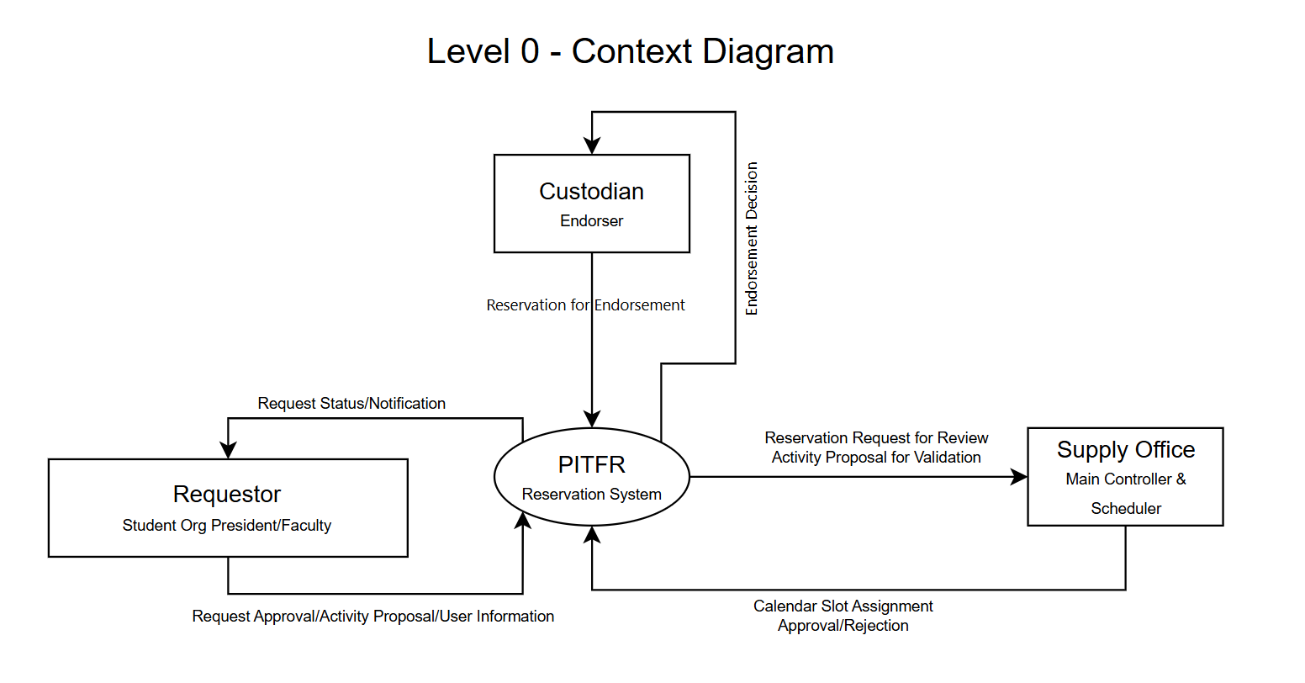

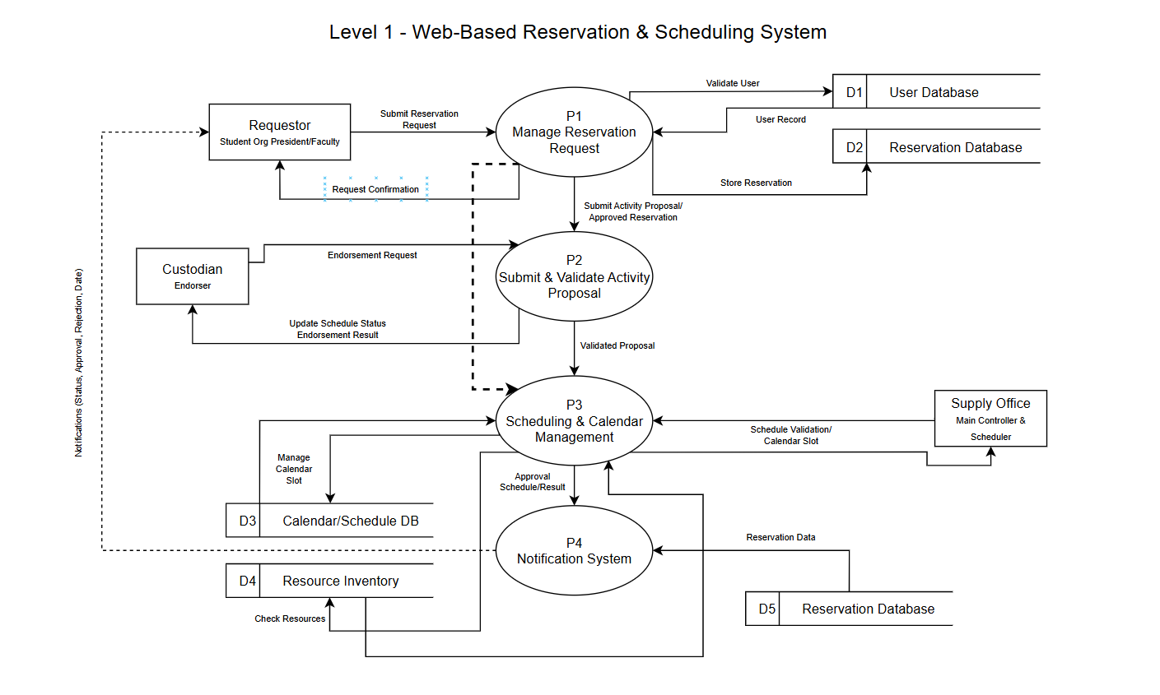
Figure 2 – Data Flow Diagram (DFD) Level 1 – Web-Based Reservation & Scheduling System

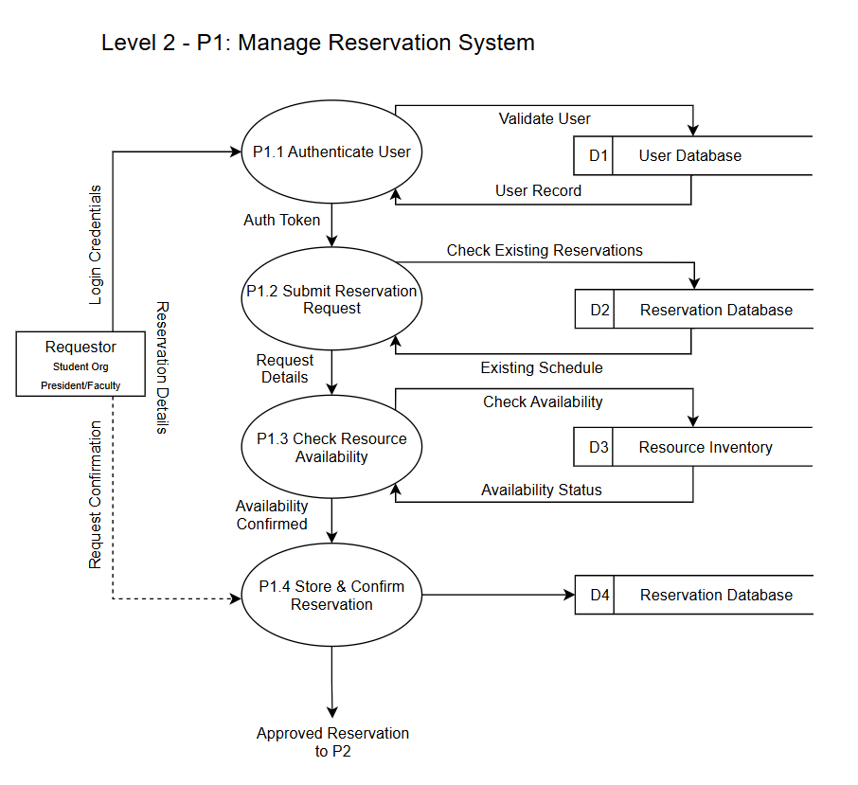
Figure 3 – Data Flow Diagram (DFD) Level 2 – P1: Manage Reservation System

Figure 4 – Data Flow Diagram (DFD) Level 2 – P2: Submit & Validate Activity Proposal
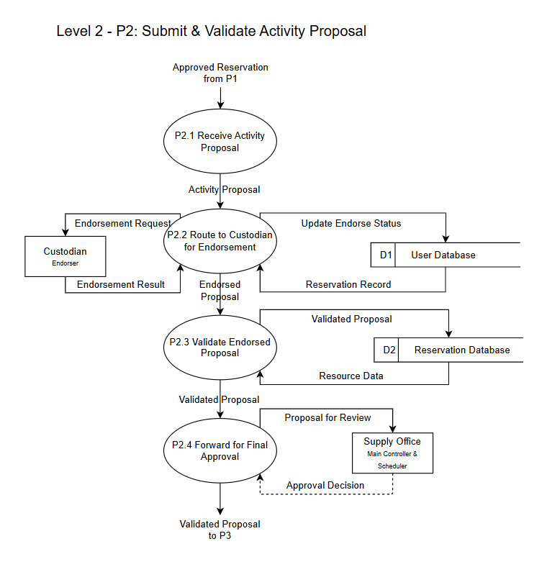
Figure 5 – Data Flow Diagram (DFD) Level 2 – P3: Scheduling & Calendar Management
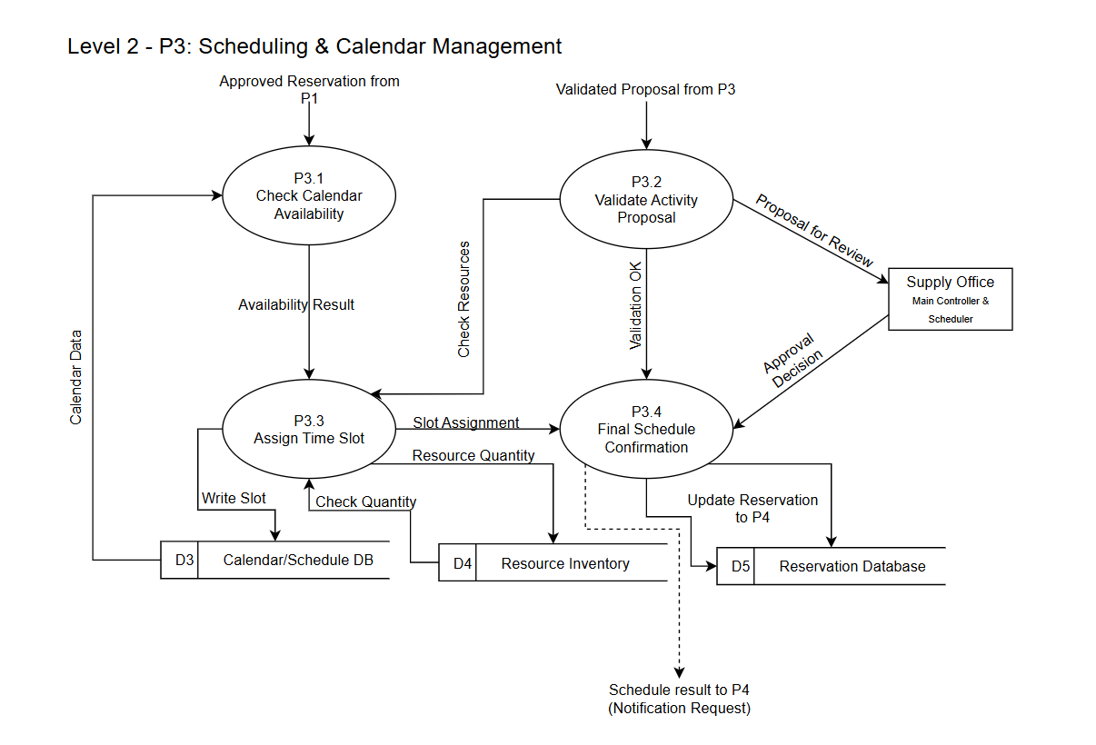
Figure 6 – Data Flow Diagram (DFD) Level 2 – P4: Notification System
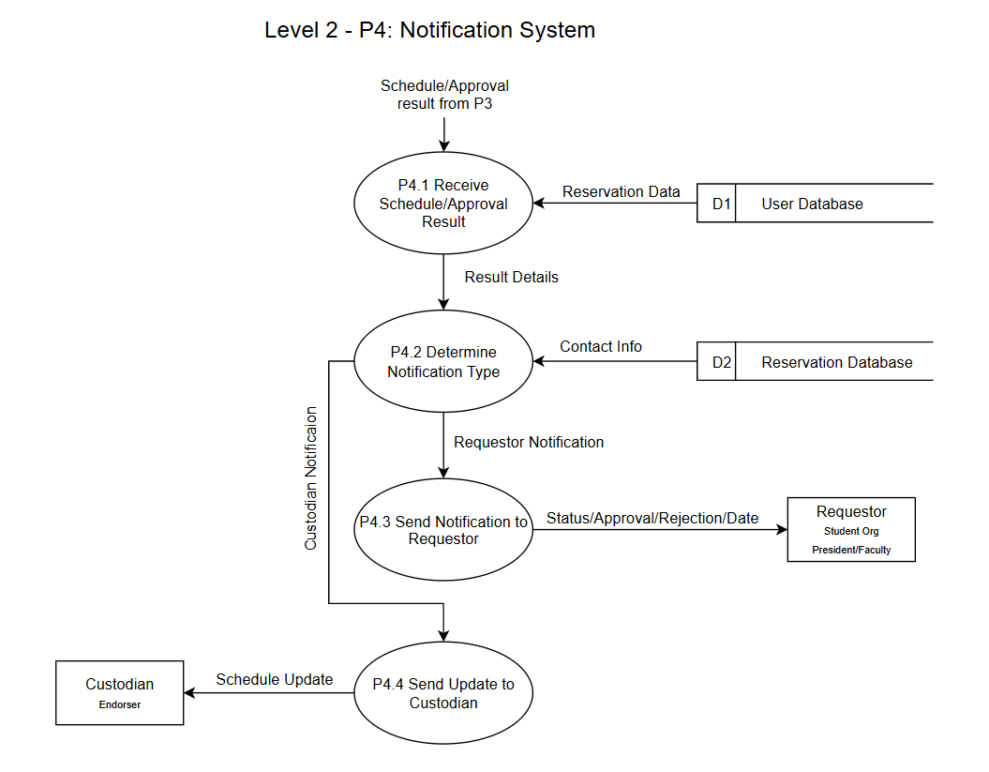

3.7 Data Gathering Procedures
Data were collected through interviews and survey questionnaires to support system development and evaluation. Interviews were conducted to identify existing problems, while surveys were used to evaluate the developed system after implementation.

3.7.1 Instruments of the Study
The study utilized a researcher-made survey questionnaire adapted from the ISO/IEC 25010 software quality standards. A 5-point Likert scale was used to evaluate system performance in terms of functionality, usability, and security. The instrument was validated by the research adviser prior to distribution.

3.7.2 Research Procedure
The following steps were followed in conducting the study:
- Conducted interviews with Supply Office personnel and system users
- Identified problems in the current reservation process
- Designed the proposed system
- Developed the web-based system
- Conducted system testing and refinement
- Distributed evaluation questionnaires to respondents
- Collected and analyzed responses

3.7.3 Gantt Chart
A Gantt chart (Figure 7) was used to monitor the progress of the project, including planning, development, testing, and evaluation phases.

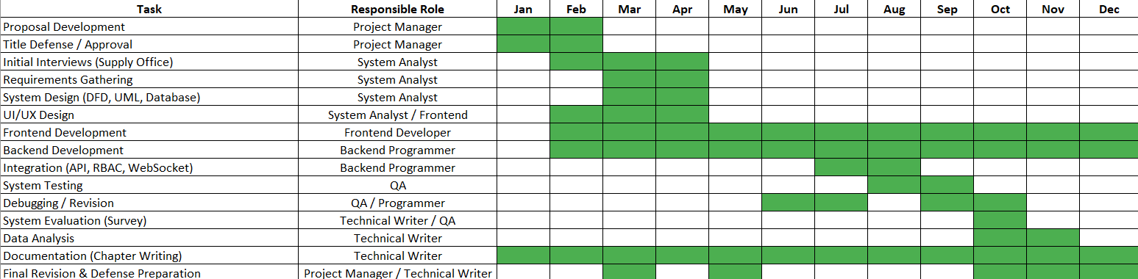
Figure 7 – Gantt Chart

  - Tools, Technologies, and Equipment
The system was developed using the following tools and technologies:
- Hardware: Desktop computers and laptops
- Software:
  - PHP (backend development)
  - MySQL (database management)
  - HTML/CSS (interface design)
  - JavaScript (client-side scripting)
- Development Tools: XAMPP (local server environment), Visual Studio Code
- Browser: Google Chrome or any modern web browser

3.9 Data Analysis
The collected data were analyzed using descriptive statistical methods such as frequency count, percentage, and mean scores. The weighted mean was used to interpret the Likert scale responses and determine the overall evaluation of the system.
3.10 Evaluation Procedure
The developed system was evaluated during the Academic Year 2026–2027 based on the following criteria:
- Functional Suitability – Accuracy of system features and workflow
- Usability – Ease of use and user experience
- Security – Protection of user data and system integrity

3.11 Ethical Consideration
The study ensured that all respondents participated voluntarily. Informed consent was obtained prior to data collection, and all responses were treated with strict confidentiality. Personal information was protected and used solely for academic purposes.

3.12 Operational Framework (IPO Model)
The study follows the Input-Process-Output (IPO) model:
- Input: User data, reservation details, resource availability, institutional policies
- Process: System development using Iterative SDLC and automated approval workflow
- Output: A functional web-based reservation and scheduling system

3.13 Project Schedule and Location
The system development and testing were conducted at Palompon Institute of Technology, specifically within the College of Technology and Engineering. The implementation phase was scheduled prior to the proponents’ fourth-year internship.

